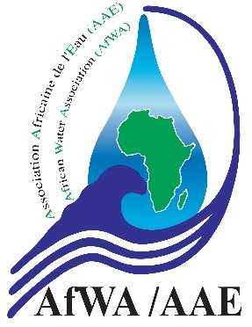
African Water Association
1st Digital Congress
July 22nd to 29th, 2022
---------------------------------------------
Summary of the paper

Title of the paper | Example: decentralized systems as an opportunity to foster access to water in African cities
Full name of the submitter | Example: Dr. Marie Olivia Konan
Expertise Area of the submitter | Example: Expert in Water Quality
Organization | Example: African Water Association (AfWA)
Contact / email | Example: Mkonan@afwa-hq.org  +225 xx xx yy yy zz
Track/theme /sub-theme | Example: Access to Water /governance systems and regulations /decentralization policy
Summary of the paper

